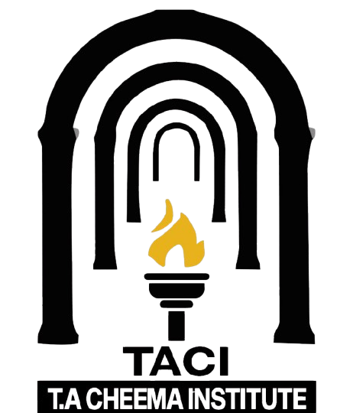
TACI BULLETIN
Scientific & Literary Forum — Scientific Forum Submission (auto-formatted)
Digital Object Identifier 10.XXXX/TACI.2026.XXXXXXX
Afghanistan: A Historical Perspective
Professor Muhammad Asghar Hashmi
Tahseen Ahmad Institute Bahawalpur

It is commonly believed that Afghanistan has been the graveyard of great empires. To examine this perception, it is necessary to view Afghanistan’s history not through emotion but through historical evidence and political context. The report presented below has been compiled with this very objective.

Introduction
The region of Afghanistan has, since ancient times, remained under the influence of various powers. However, it would be more accurate to say that rather than becoming the graveyard of empires, this land has more often served as a permanent battlefield and a center of political contestation for global powers.
Although Afghanistan has been a crossroads of ancient civilizations, its emergence as a modern state became prominent in the nineteenth century when the British and Russian empires stabilized it as a buffer state between themselves. Britain sought to protect its Indian dominion from northern threats, while Russia was exploring avenues for southward expansion. Consequently, Afghanistan became a geopolitical entity whose internal politics and foreign relations were frequently shaped by the pressure of major powers.

Historical Journey
A. The Achaemenid Empire
From 550 to 330 BCE, much of present-day Afghanistan formed part of the Achaemenid Empire. Although the capital of Cyrus the Great’s realm was Persepolis, Afghanistan was incorporated into its provincial administrative structure. Local rulers remained subordinate to central authority.

B. Greek Influence
In 330 BCE, after conquering Persia, Alexander the Great also took control of Afghan territories. Greek influence spread across Kabul, Balkh, and Bamiyan, and the Seleucid Empire later maintained this domination.

C. The Maurya Empire
Between 305 and 185 BCE, Chandragupta Maurya’s empire absorbed the southern regions of Afghanistan. Buddhism flourished during this period, although political authority remained firmly centralized.

D. The Sassanian Period
From 240 to 651 CE, Afghanistan at various times fell under the influence of the Sassanian Empire. The region was regarded as a strategically important frontier zone in Iranian political geography.

E. Islamic Conquests
Following the rise of Islam, large parts of Afghanistan were incorporated into Muslim polities during the Rashidun, Umayyad, and Abbasid periods. Herat was captured in 642 CE, and the region was administered from the imperial capital.

F. The Samanids and Ghaznavids
From the ninth to the twelfth centuries, the Samanid and later the Ghaznavid dynasties ruled the region. Under Sultan Mahmud of Ghazni, Afghanistan became a major military and political center.

G. The Ghurids, Mongols, and Timurids
Between the twelfth and fifteenth centuries, the Ghurid, Mongol, and Timurid eras followed one another. In 1219, Genghis Khan’s invasion brought widespread devastation. Later, Timur made Herat his capital, enabling Afghanistan to emerge as a center of learning and culture.

H. Mughal Influence
In 1504, Babur captured Kabul and made it the base for his Indian campaigns. Afghanistan remained under Mughal influence until the reign of Aurangzeb.

I. Nader Shah and the Durrani Empire
In the eighteenth century, Nader Shah Afshar seized Kandahar and Kabul. In 1747, Ahmad Shah Abdali established the Durrani Empire—marking the first time Afghanistan appeared as a relatively independent state, though it remained caught in regional power rivalries involving Iran, Central Asia, and the Indian subcontinent.

J. British and Russian Pressure
During the nineteenth century’s “Great Game,” Afghanistan became the arena of rivalry between Britain and Russia. Three Anglo-Afghan wars were fought, the Durand Line was drawn, and for a prolonged period Afghanistan’s foreign policy remained under British influence.

K. Soviet and American Interventions
In 1979, Soviet forces entered Afghanistan and withdrew ten years later. In 2001, American and allied forces arrived, departing in 2021.

L. Conclusion
At every major turning point, Afghanistan stood at the center of global politics. Nevertheless, it would be more cautious to state that Afghanistan was not entirely subjugated by external powers, as local rulers and resistance movements existed in every era.
Thus, rather than calling Afghanistan the “graveyard of empires,” it is more appropriate to describe it as a region that has, for centuries, remained a focal point of confrontation among great powers.
Afghanistan — Historical Timeline
1. Ancient and Classical Period
Year/Period | Empires Detail
550–330 BCE | Achaemenid Empire
330–305 BCE | Alexander the Great
305–185 BCE | Maurya Empire
240–651 CE | Sassanian Empire

2. Islamic Caliphates
Year / Period | Event
642 CE | Muslim conquests
661–750 CE | Umayyad Caliphate
750–870 CE | Abbasid Caliphate

3. Regional Muslim Dynasties
Period | Dynasty / Event
819–999 CE | Samanids
977–1186 CE | Ghaznavids
1148–1215 CE | Ghurids

4. Mongol and Timurid Period
Year / Period | Event
1219 – 1370 CE | Genghis Khan's invasion
1370–1507 CE | Timurid Empire

5. Mughal and Iranian Rule
Year / Period | Event
1504–1707 CE | Mughal influence
1728 – 1747 CE | Nader Shah Afshar

6. Afghan State Formation
Year / Period | Event
1747–1826 CE | Durrani Empire

7. Colonial-Era Pressure
Year / Period | Event
1839–1842 CE | First Anglo-Afghan War
1878–1880 CE | Second Anglo-Afghan War
1893 CE | Durand Line
1919 CE | Third Anglo-Afghan War

8. Modern Global Interventions
Year / Period | Event
1979–1989 CE | Soviet presence
2001–2021 CE | U.S. and allied forces
2024 – Todate | Pak – Talban War

